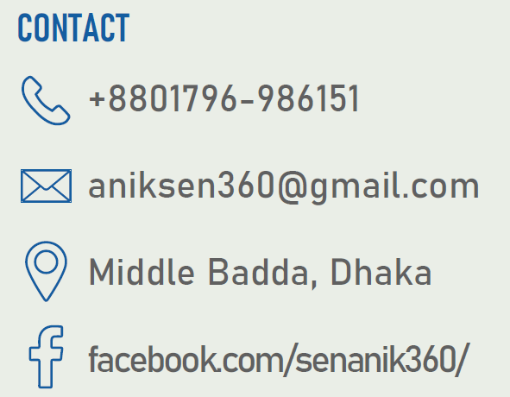

**Anik Sen**

**Personal Profile -**

I am currently pursuing a Bachelor of Science in Computer Science & Engineering, specializing in Software Engineering, at American International University-Bangladesh (AIUB). I have successfully completed all the required credits for my degree, with the exception of the internship. As I am eager to embark on a career in the IT industry, I am actively seeking job opportunities and dedicating myself to enhancing my skills in programming and acquiring knowledge of various software and tools. My commitment to continuous learning underscores my preparation for a successful future in the field.

**Education and Training -**

|  |  |  |  |  |
| --- | --- | --- | --- | --- |
| **Institution** | **Degree** | **Department/Group** | **GPA/CGPA** | **Passing Year** |
| **American International University-Bangladesh** | BSc | CSE | **3.94** out of **4** | 2023 |
| **Sreemangal Govt. College** | HSC | Science | **4.83** out of **5** | 2018 |
| **Saint Martha’s High School** | SSC | Science | **4.61** out of **5** | 2016 |

|  |  |  |
| --- | --- | --- |
| **Organization** | **Role** | **Period** |
| **ETech Solution** | Cloud Computing Intern(Weekend Program) | June, 2023 to Present |
| **Youth School for Social Entrepreneurs – YSSE** | Communications Intern (Remote) | March - August, 2023 |
| **a1qa (Minsk, Belarus)** | QA Functional Testing Intern (Remote) | April - May, 2023 |

**Experience -**

**Skills Summary -**

* Proficient in multiplePrograming Language- **C, C++, Java, C#, Python[Numpy, Pandas,** **Seaborn,** **scikit-learn], JavaScript, Php**
* Proficient in Backend Framework- **ASP.NET**
* Experienced in **HTML5, CSS3, Bootstrap5**
* Experienced in **Microsoft Office**
* Database Management – **My Sql, MS Sql**, **PL Sql**
* Experienced in Software Testing tool- **Selenium with Java**
* Problem Solving in different online judge- **Codeforces, Beecrowd, Hackerrank**
* Googling
* Teamwork
* Communication
* Research
* Leadership

1. **Tour Guide – BD**

**Projects -**

* Using C# Web Form, based on the knowledge of Object Oriented Programming-2(C#) course

[*https://github.com/senanik360/tour-guide-C-sharp*](https://github.com/senanik360/tour-guide-C-sharp)

1. **Online Super Shop**

* Using basic Java. It’s a console application based on the knowledge of Object Oriented Programming-1(Java) course

*https://github.com/senanik360/Java*

1. **Tourism Management**

* It’s a web application (Used HTML, CSS, PHP, JavaScript, MySQL )

*https://github.com/senanik360/WebTech_course_project*

1. **Graphical view of Sea Beach**

* A graphical view of sea beach using C++ OplenGL

[*https://github.com/senanik360/Computer-Graphics*](https://github.com/senanik360/Computer-Graphics)

**Portfolio -**

 github.com/senanik360

 linkedin.com/in/senanik360/

**Participation and Certification -**

* **DUET TechFest 2k23. Winner** of the segment of the “Idea & Project Exhibition”: project Title - ***Sign Language to Speech Converter***
* **Orbitax SUST SWE Technovent 2023(Brain Station 23 Hackathon).** Successfully passed first round and participated final round at SUST campus for 36 hour non-stop on site hackathon.
* **MIST LeetCon 2023.** Participated in the cyber security workshop, titled **"HackMeIfYouCan."**
* **CTO forum Innovation Hack-a-Thon 2022.** Successfully passed first round and reached second round (prototype).
* **Professional English Communication and Training.** A training period under **SEIP** and **BASIS**, organized by **WSDA New Zealand**.
* **Php with Laravel.** A training course under **SEIP** at Pencil Box training centre (Government funded).
* **CISCO – IT Essentials.** Successfully achieved student level credential by completing IT Essentials course
* **Cyber Security & Social Awareness Program-2022: A Deep Drive into the Modern Day Security.** Organized by Career Pro BD at AIUB

**Awards / Honours -**

* **FST Dean’s List Honour** based on academic excellence. [*Five Times for Five Consecutive Academic Session*]
* **AIUB Academic Scholarship** based on academic results. [*Till Last Semester*]

**Extra-Curricular Activities -**

- Campus Ambassador [Team Lead] at **ICT Olympiad Bangladesh – 2022** (Season 1)

- Organizer at **AIUB Arts Club**

- The Duke of Edinburgh’s International Award (**Bronze**)

- Volunteer at **Bangladesh Red Crescent Society**

**References Available on Request -**

|  |  |
| --- | --- |
| Dr. Akinul Islam Jony  Associate Professor and Head (UG), Computer Science, AIUB  Email : [akinul@aiub.edu](mailto:akinul@aiub.edu)  [Academic] | Dr. Kamal Uddin Sarkar  International Faculty, Department of Informatics, Universiti Malaysia Terengganu  Email : [kusarker@umt.edu.my](mailto:kusarker@umt.edu.my)  [Academic] |